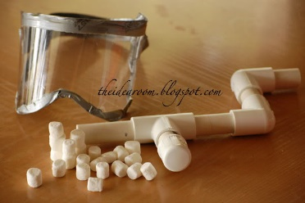
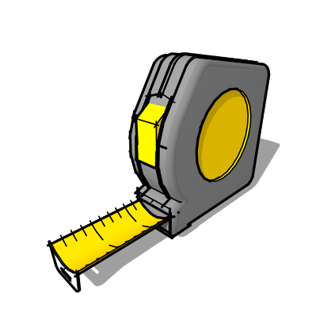
Isle of Wight Academy presents
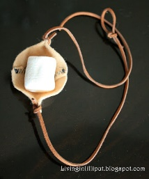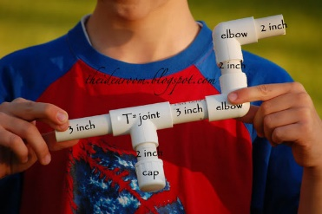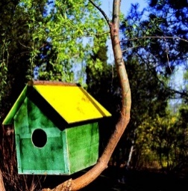 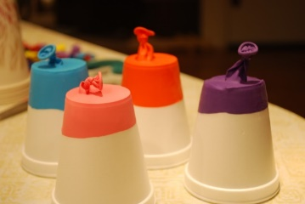
- Kids will learn useful skills
- experiment with different tools (hot glue gun hammer screw driver kitchen knife spray paint) and materials
- Students will build and create their very own Projects and Food from ideas inspired by pinterest & blogs (water balloon launcher, MARSHMALLOW shooter, & fizzy sherbet to name a few)

Space is Limited – No Refunds
Camp Shirt Included
Email: juliahooper@iwacademy.com
Make Checks Payable to Julia Hooper
Register by May 30th
DIY MAKERS CAMP
Date: June 24-27
Time: 9-12
Grades: 4th – 6th
Cost: $115.00 per student

ISLE OF WIGHT ACADEMY
DIY Makers Camp
June 24-27
9:00 am–12:00pm
COST: $110 PER STUDENT

PLEASE SEND CASH OR CHECK PAYABLE TO JULIA HOOPER BY MAY 29TH
LIMITED SPACES AVAILABLE! NO REFUNDS!
Description: Students Will Have The Opportunity To Learn To Use Different Tools (hot glue gun hammer screw driver kitchen knife spray paint) And Materials To Test Their Creative Thinking Skills. Explore The World Of DIY Projects That Are Fun To Make And Fun To Eat.

STUDENT INFORMATION: CHILD'S NAME: _________________________________
CHILD'S GRADE LEVEL FALL 2019: _______________________
PARENT'S NAME: ______________________________________________________
CONTACT NUMBER AND EMAIL: _________________________ ________________
MEDICAL CONDITIONS/ALLERGIES: ______________________________________
IF YOU HAVE ANY QUESTIONS, PLEASE CONTACT THE TEACHER: Julia Hooper
juliahooper@iwacademy.com 757- 357-3866

WAIVER
I HEREBY WAIVE AND RELEASE THE IWA "DIY MAKERS CAMP” DIRECTORS AND STAFF, AND ISLE OF WIGHT ACADEMY FROM ANY AND ALL LIABILITY FOR ANY INJURY MY CHILD MAY SUSTAIN WHILE AT THE IWA DIY MAKERS CAMP.

PARENT/GUARDIAN SIGNATURE: _______________________________________
DATE: ______________________
IN CASE OF AN EMERGENCY, IF PARENT/GUARDIAN CANNOT BE REACHED, PLEASE CONTACT NAME: ____________________________________________
CONTACT NUMBER: _________________________________________________

