IWA Snack Order 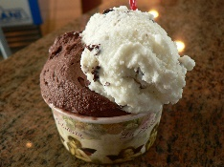
Teacher _______________ Room ______ Date_________
Item | Cost | Name | # | Amount
Vanilla Cup | $1.25
Chocolate Cup | $1.25
Strawberry Cup | $1.25
Ice Cream Sandwich | $1.25
Fudge Bar | $1.25
Orange Cream Bar | $1.25
Turbo Tube | $1.50
Nutty Buddy | $1.50
Chocolate Milk | $ 1.00
Plain Milk | $ 1.00
Chocolate Crunch | $1.50
Strawberry Crunch | $1.50
Popsicle | $ .75
Granola Bar | $ .75
Snack Items | $.75
 |  | Total Order =

