IWA Lunch Order 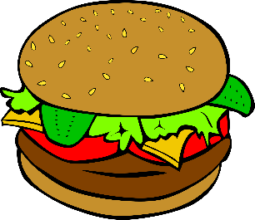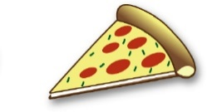
Item | Cost | Name | # | Amount
Hot Lunch | $5.00
Large Salad | $4.00
Small Salad | $2.50
Hot Dog | $2.50
Pizza | $3.00
BBQ | $3.00
Chicken Sandwich | $3.50
Hamburger  Tues/Thurs | $3.25
Cheeseburger  Tues/Thurs | $3.50
Granola Bar | $ .75
Chocolate Milk | $ 1.00
Plain Milk | $ 1.00
Apple Juice | $1.50
Sunny D Orange  Drink | $1.50
Nabs | $ .75
Sweet Soft Rolls | $1.50
Snack Items | $ .75
Small Water | $ .10
Large Water | $ .15
Soda | $1.25
Gatorade | $2.00
Candy Bar | $1.50
 |  | Total Order =

